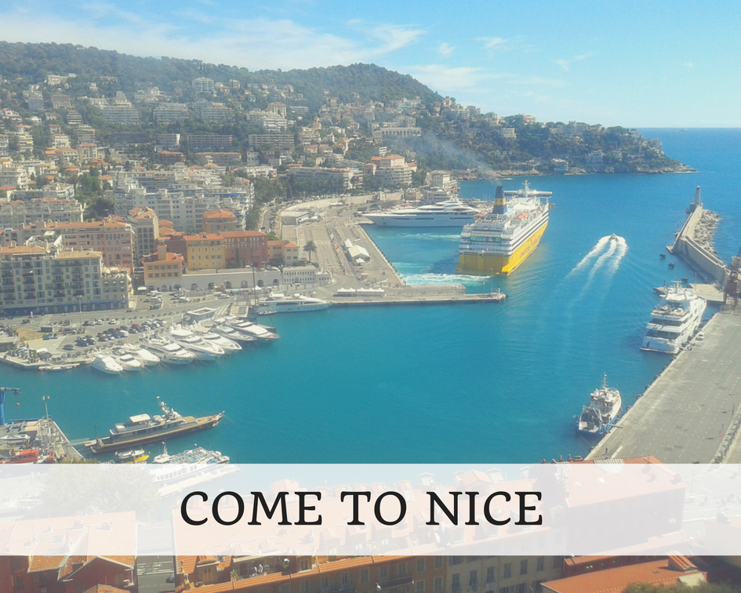
Helloooooo....

Have you been to Nice in France?
This postcard shows the traditional view of this seaside town but there is so much more here.
As you might expect, everything about Nice has been done in the best possible taste (this is often reflected in the prices), but it is a great town to explore.
It’s also a great jumping off point for many other villages and towns all along this Mediterranean coastline with great bus and rail links.
I took myself off for a day on the bus and I explored the little principality of Monaco.
One word of warning here – Monaco is hilly. In fact, Monaco is more than hilly, it’s mountainous!
At least the government do their best to make things a little easier for you and there are many elevators dotted around the hillsides which will get you up and down at key points. And Monaco is even more expensive than Nice for things like coffee and lunch, but it’s still a nice place to wander around.
Nice surprised me with a Russian Orthodox Cathedral complete with onion shaped roofs, a sleek tram system and some huge parks which had some of those cool water features – the sort where you walk across a plaza and you are surprised by jets of water blasting up from the paving stones.
There are smart boutiques and quaint little backstreets, there are chic wine bars and posh restaurants and there are miles of golden sandy beaches with parasols fluttering in the wind.
In places, it’s like stepping into a postcard from the nineteen thirties with promenading and people watching taking top priority.
I stayed in an AirBnB apartment with my parents with a cute little balcony. If you have never used AirBnB before you can use this link and get a voucher for money off your first stay www.airbnb.com/c/jclements58.
Shall I continue to send you postcards from my travels?
Are you enjoying them?
Do you wish that you were here?
Love from Jane (Scarlet Jones)

Here is the link to my book ‘Becoming Stronger Through Mindfulness’: https://payhip.com/b/vfx7

