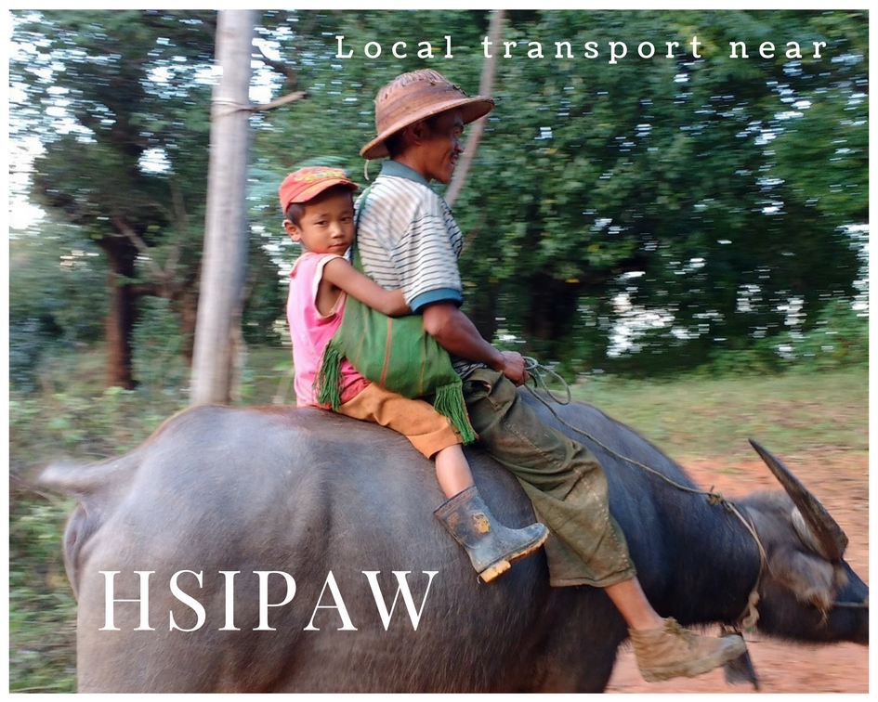
Hello from the mountain town of Hsipaw in Myanmar.

Wish you were here really is the truth!
I am totally in love with Myanmar and her people who are all quite beautiful inside and out, and each place that I stay is even better than the last. My trip has varied between crazy cities and beautiful countryside, lakes and ancient sites; and now I’m up in the north in the mountains at a small town called Hsipaw (pronounced Seepaw).
The best bit about Hsipaw had to be the trekking and the homestay that I did in the mountains but the second best bit was the journey to and from Hsipaw.
My friend Ibti and I opted to take a private car and driver up over the mountain from Mandalay. It sounds a bit flash but to be honest it was very cheap and the car wasn’t exactly luxurious.
We were squashed in the back with another traveller and a quiet local lady who sat in the front passenger seat. Before setting off we first had to drive around the town while our driver collected sacks and boxes which he battled to fit into the boot.
Once there was no more room in which to squeeze a mouse we were off. I reckon our driver must have binged on Fast & Furious and Grand Theft Auto and he certainly fancied himself as a rally driver. He had two speeds – super-fast and warp-speed, although I have to say, that once he had proved himself around the first few hairpin bends I relaxed and trusted his skill.
The mountain roads are tortuous and have heavily laden lorries transporting stones from the quarries crawling up and down them. Whole stretches of road are given over to rest places where men dash out with huge wooden sleepers and rocks to wedge under the lorry wheels whilst they hose the smoking brake drums and wheels down with cold water.
In the distance we could see the delicately thin spider web of the Goeteik viaduct crossing the valley– and which a few days later I would cross on what is one of the world’s epic train journeys.

Our trek with our guide Sai was the best thing ever. Six of us set off up, up and up into the mountains. It was tough going but so beautiful and worth the struggle. Our homestay was in a tiny little mountain village where the family opened their house to us. They cooked on an open fire on the first floor of the living area. The wooden house was built on tall stilts and the sweetest buffalo lived below. We had mattresses on the floor with mosquito nets and the ladies cooked tasty, fresh and wholesome food for us. The bathroom was a hut with a large water tank, the shower a jug of cold water and at night we sat around a campfire under a magnificent star show.
We passed rural life unchanged for decades and villages with tiny children running barefoot and cared for by grandparents and where cooking was done over open fires. We passed military checkpoints and I took one of my favourite photos EVER.........but for security reasons I am unable to share it with you.
Picture this. Hiking up a steep hill side, all hot and sticky and approaching a mountain village with its obligatory checkpoint/security patrol.
A fresh-faced ‘soldier’ dressed in military fatigues and wearing a khaki cap sits in front of a barrier on a bench fashioned out of a fallen tree trunk. Like most men in Myanmar he has a beautiful face with dark, almost black eyes and is of average build. Everything are earthy shades from the green jungle trees, the grass and the creepers, the rich terracotta earth and the soldier’s uniform, boots and rifle which is slung over his shoulder.
But, in all of this is a vivid splash of pink. The soldier is sat and bouncing his baby just a couple of months old on his lap. His little daughter with skin the colour of a cappuccino coffee is wrapped up in a fleecy, furry pink jacket and has been brought up by his wife for a visit.
Breaking the rules about not photographing military I dared to ask with sign language if I could take his picture. He looked at me looked at the group and then slowly stood. I assumed that he was going to decline, but no, he stood to pose for me so that I could also get the benefit of the spectacular valley behind him.
I rapidly snapped off a series of shots – capturing the incongruous moment of an unofficial soldier enjoying time with his baby.
And I was then warned that to post his picture and to identify him with his gun could hold serious repercussions for him.
I respect that and I treasure the picture. If we meet in person I can show you the photo but you will not find it on any of my social media.

The BEST bit of travel are the people that you meet and the experiences that unfold when you least expect them.

If you want the best guide for Hsipaw whether trekking or by motor bike contact me for Sai’s details, or alternatively, book him via Mr Charlies guesthouse in Hsipaw.

Do you like these postcards that I am sending you? I’m not sure where the next one will come to you from as my time in Myanmar is nearly over.
If you want to travel with me drop me a line and if you have friends that might like to get these postcards, send them this link:- https://www.scarletjonestravels.com/get-virtual-postcard/
Bye for now and we’ll chat again very soon, love from Jane xxx

